Spirituality, Holy Habits and Mission

Christian spirituality is that which fires us up and gets us in tune with God’s purposes for the world and enables us to live as faithful followers of Jesus. It can be said to be an openness to the Holy Spirit in our lives.

One pattern for spiritual growth Holy Habits - Acts 2: 42-47
⁴² They devoted themselves to the apostles’ teaching (1) and fellowship (2), to the breaking of bread (3) and the prayers(4).
⁴³ Awe came upon everyone, because many wonders and signs were being done by the apostles. ⁴⁴ All who believed were together and had all things in common (5); ⁴⁵ they would sell their possessions and goods and distribute the proceeds to all, as any had need (6). ⁴⁶ Day by day, as they spent much time together in the temple, they broke bread (3) at home and ate their food together (7) with glad and generous hearts (8), ⁴⁷ praising God (9) and having the goodwill of all the people. And day by day the Lord added to their number those who were being saved (10).

- Biblical teaching
- Fellowship
- Breaking of bread
- Prayer
- Sharing resources

- Serving
- Eating together
- Gladness and generosity
- Worship
10.. Making more disciples

On your own – 2 minutes
1. list all the different things that your churches/organisations currently do that are ‘outward-facing’ and therefore missional
(i.e. not just for the existing attenders/members)
2. Highlight the ones that you are involved in
3. List all the other types of mission activity in this country and abroad that you are involved in by doing or through donating goods or money through your local church, or community and across the UK and globally

In groups of 3: - 10 minutes
On a large sheet of paper with three columns for Proclamation, Practical action and Prophetic Action (see next page for classifications)
Using a different coloured pen each, list all the activities you are each involved with
Is there a pattern ?
Does anything surprise you about that ?
What might that say to you about your spirituality ?
Is there any connection between the Gospel passage you have been writing about and the sorts of mission you are currently involved in ?

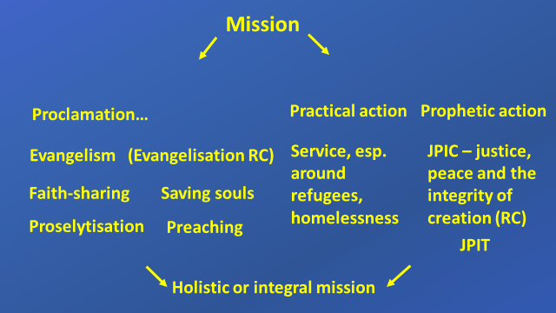
©Erica Dunmow

